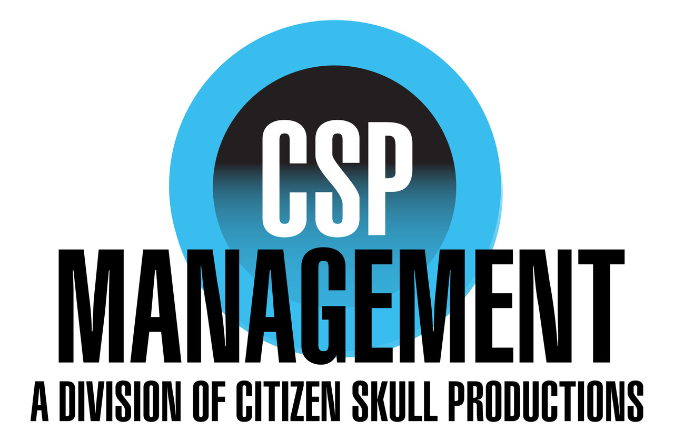  Lanette Mastandrea  lmastandrea@citizenskull.com  323-302-4242 x124 |  |  | Jake Millgard  AEA/SAG-AFTRA  www.JakeMillgard.com  Vocal: Tenor (D3-B4) |  |  | Member since 2018

Film/TV
Danger Force  Grimm |  |  | Chunk Manlee/D. Face(Guest Star)  Paramedic(Co-Star) |  | Nickelodeon  NBC Universal |  | Michael D. Cohen  Norberto Barba
Packed |  |  | Jake(Lead) |  | Storiation |  | Robert Vornkahl
Another Castle |  |  | Mr. Dixie(Lead) |  | Popcorn and Wine |  | Sara Werner
Frank and Barry |  |  | Frank (Lead) |  | V3 Productions |  | Robert Vornkahl
Hall Pass |  |  | Chubby Guy(Lead) |  | MTV |  | Tom Coleman
Drunken Exercise |  |  | Man in Bar(Under 5) |  | The Onion |  | Langhorn Fisher
Hula Girl |  |  | Hogan(Lead) |  | NYU |  | Dan Erickson
Pudding Face |  |  | Howie(Lead) |  | Oven Feast Productions |  | Emily Berthold
Black Sisyphus: Myth and More |  |  | Mormon(Supporting) |  | NWB Imaging |  | Michael Taylor
Placebo |  |  | Ben (Supporting) |  | 305 Media Group |  | Justin Ho
*Commercial & Voice Over Resume Upon Request
Theatre
Fly+ |  |  |  | Swing, Hook(uds) | La Jolla Playhouse |  | Jeffery Seller
The Christmas Story |  |  |  | Old Man | SDMT |  | Kristen Chandler
The Underpants |  |  |  | Cohen | The Old Globe |  | Walter Bobbie
Pride and Prejudice |  |  |  | Colllins, Wickam, Miss Bingley | Cygnet Theatre |  | Rob Lutfy
Midsummer Nights Dream+ |  |  |  | Bottom, Theseus | The Old Globe |  | Patricia McGregor
Barefoot in the Park |  |  |  | Telephone Repair Man | The Old Globe |  | Jessica Stone
Benny and Joon |  |  |  | Benny, Sam, et al. (uds) | The Old Globe |  | Jack Cummings III
Guys and Dolls |  |  |  | Lt. Branigan | The Old Globe |  | Josh Rhodes
Measure for Measure+* |  |  |  | Lucio | The Old Globe |  | Patricia McGregor
Love’s Labour’s Lost+ |  |  |  | Dull | The Old Globe |  | Kathleen Marshall
Macbeth+ |  |  |  | Angus | The Old Globe |  | Brian Kulick
The Comedy of Errors+ |  |  |  | Jailer, Courtesan(uds) | The Old Globe |  | Scott Ellis
Arms and the Man |  |  |  | Bluntschelli (uds perf) | The Old Globe |  | Jessica Stone
Dracula+ |  |  |  | Butterworth | Actors Theatre of Louisville |  | William McNulty
A Christmas Carol |  |  |  | Krookings | Actors Theatre of Louisville |  | Wendy McClellan
The Full Monty |  |  |  | Marty | Northern Stage |  | Brooke Ciardelli
Clybourne Park |  |  |  | Karl/Steve | Old Globe/USD MFA |  | James Vasquez
+Fight Captain *Fight Director
Education/Training
Old Globe/University of San Diego Shiley Graduate Acting Program- MFA
Actors Theatre of Louisville- Professional Intern Company
Groundlings- Improv Training
Western Washington University- BA Theatre Arts
 | Acting: | Richard Seer, Ray Chambers, Jon Jory, Marc Masterson, KJ Sanchez (devised work)
 | Shakespeare: | Ray Chambers, Jan Gist
 | Voice: | Jan Gist (Voice and Speech), Pamela Vanderway (Dialects) , Heather Dudenbostel(Singing)
 | Stage Combat | Brian Byrnes
Special Skills
SAFD Recommended Pass (Single Sword, Unarmed) SAFD Basic Pass (Broadsword, Rapier/Dagger, Quarterstaff), Improv Skills, Good ear and quick study with Dialect Work.

